|  |
| --- |
| **Gift Optimizer** |
| Avoids Duplicates |
|  |
|  |
|  |
| **Sandeep Keshetti** |
| **11/4/2013** |
|  |

**Introduction:**

The main intention of this application is to avoid the duplicate gifts from the several attendees to a party or any event. In this application inviter uploads some gifts and their location under his profile. And others can able to select them by sending invitation. Once one of the gift is selected by one user then it is not available to others. so that it can avoid the duplicate gifts.

**Technologies Used**:

**Languages** : Java, JDBC, Servlets and JSP

**Web Technologies :** HTML, JavaScript and CSS.

**Server :** Tomcat 7.0

**Database** : MySql Server

**Class Diagram:**

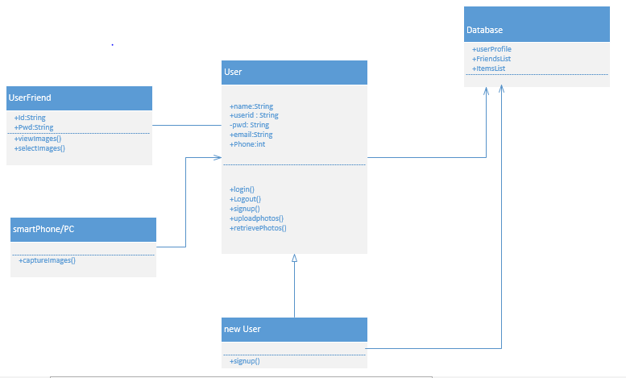

**Architecture and Design:**

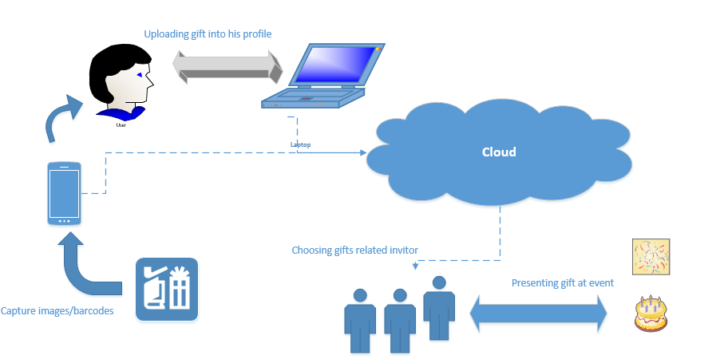

**Limitations:**

1) Application will read the barcode, barcode scanner is not implemented in this application.

2) Need to provide the certain gifts to the particular user. so that the inviter can select from them.

**References**:

Source code for the web pages are used from my current and previous projects that are done during the last semester.

**Screen Shots**:

Home Page

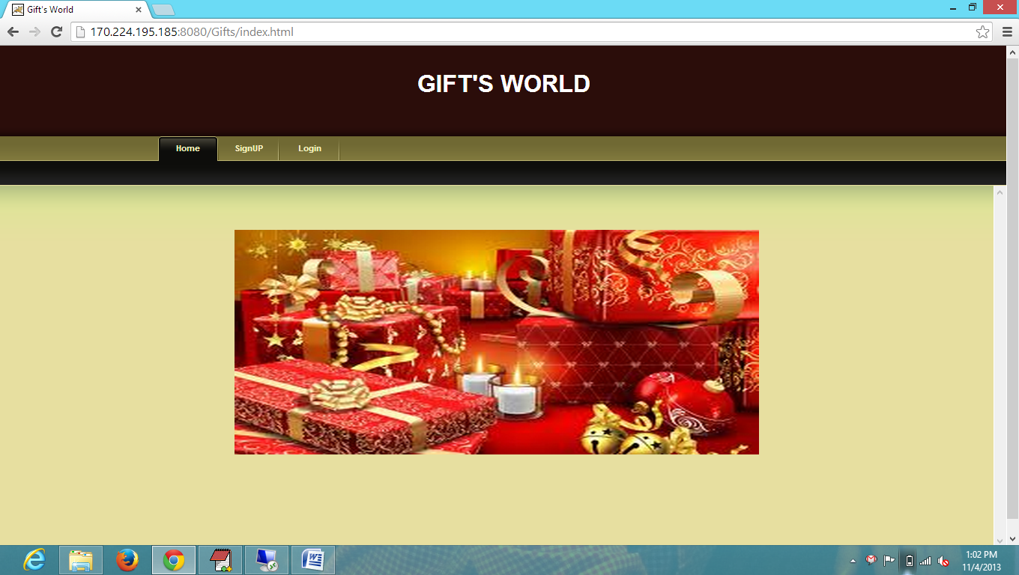

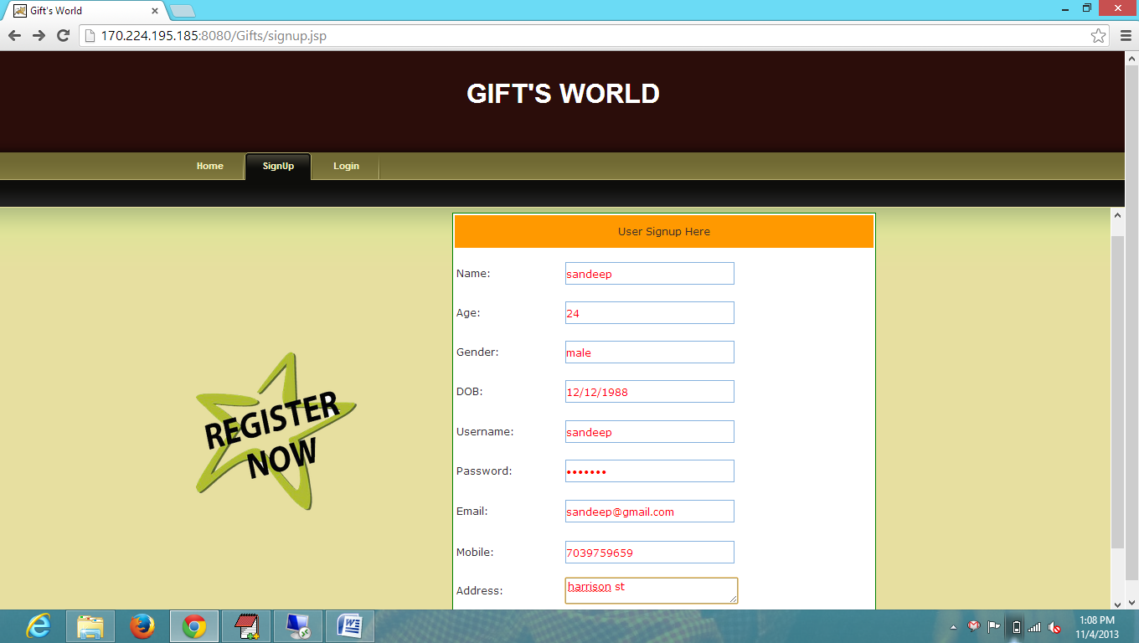

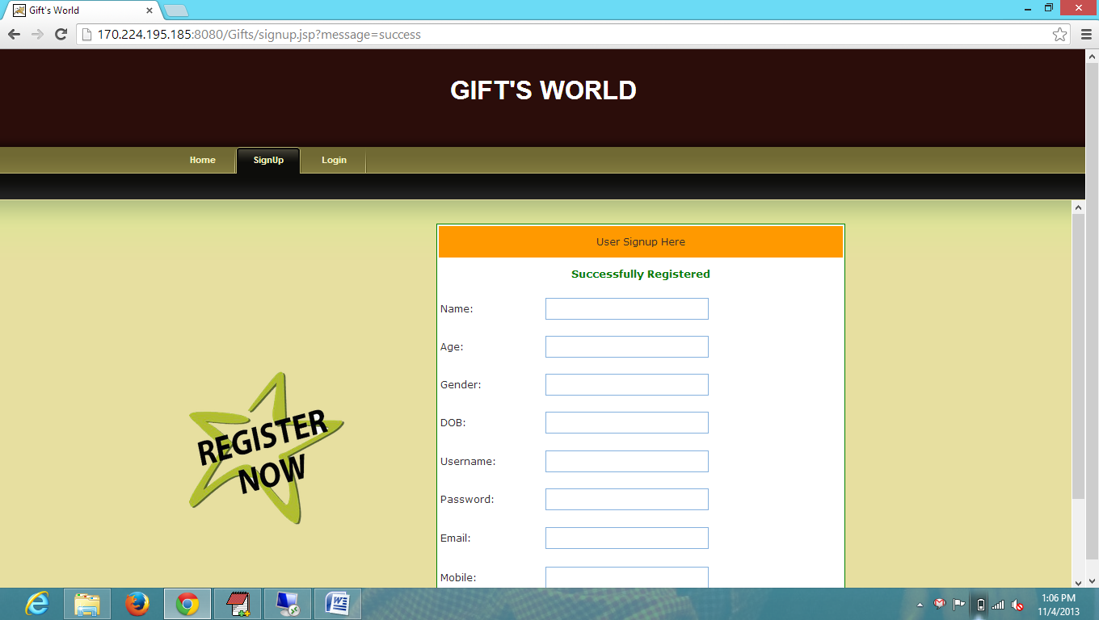

Similarly sign up for two more users  
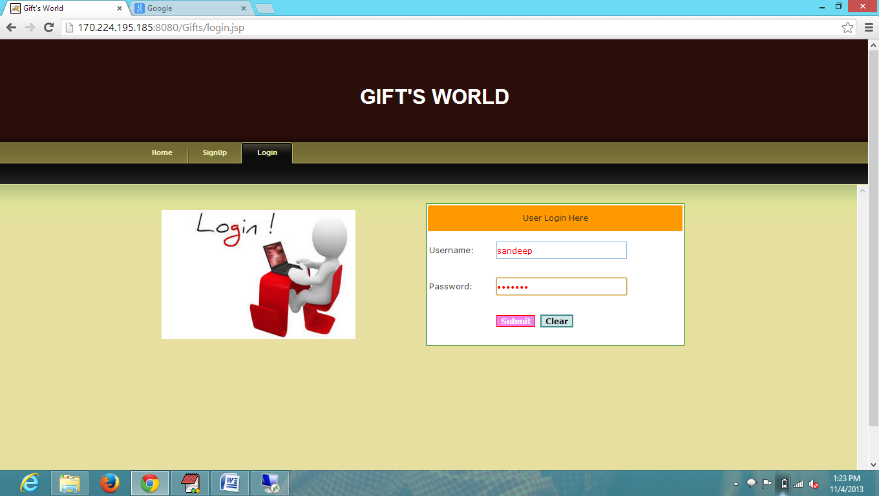  
  
  
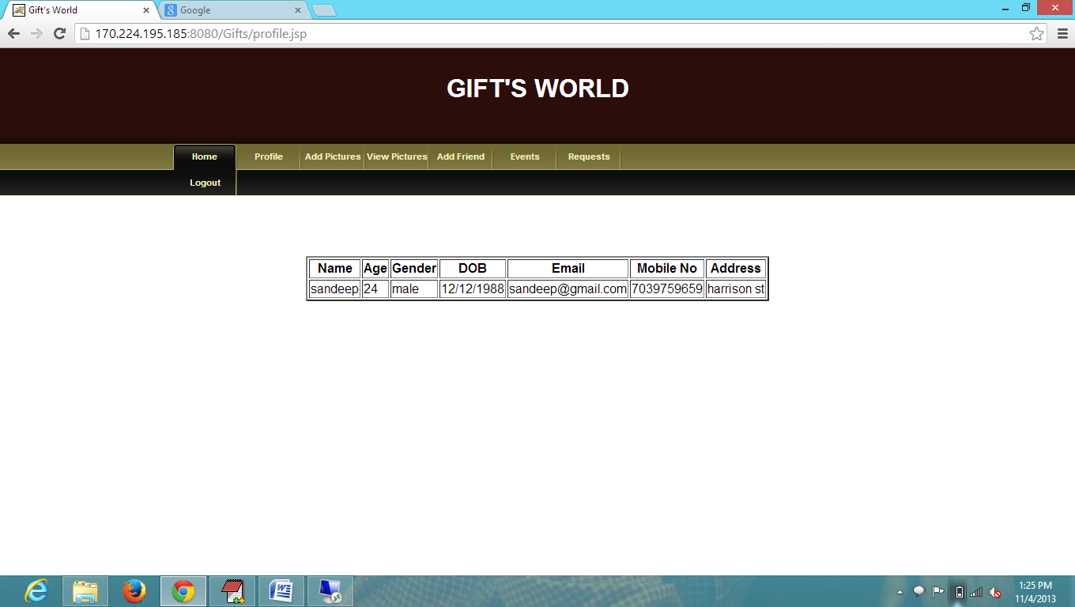

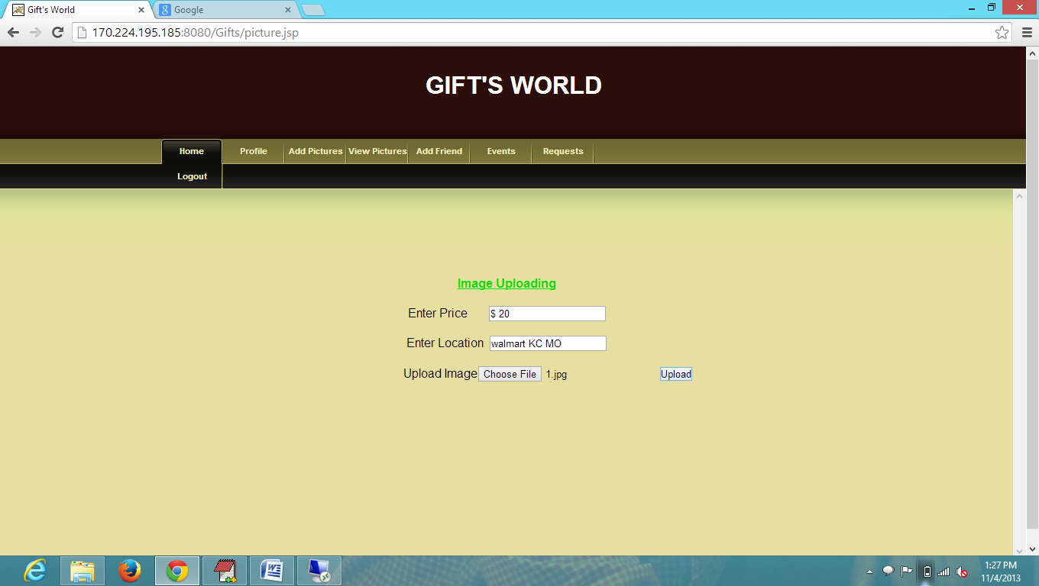

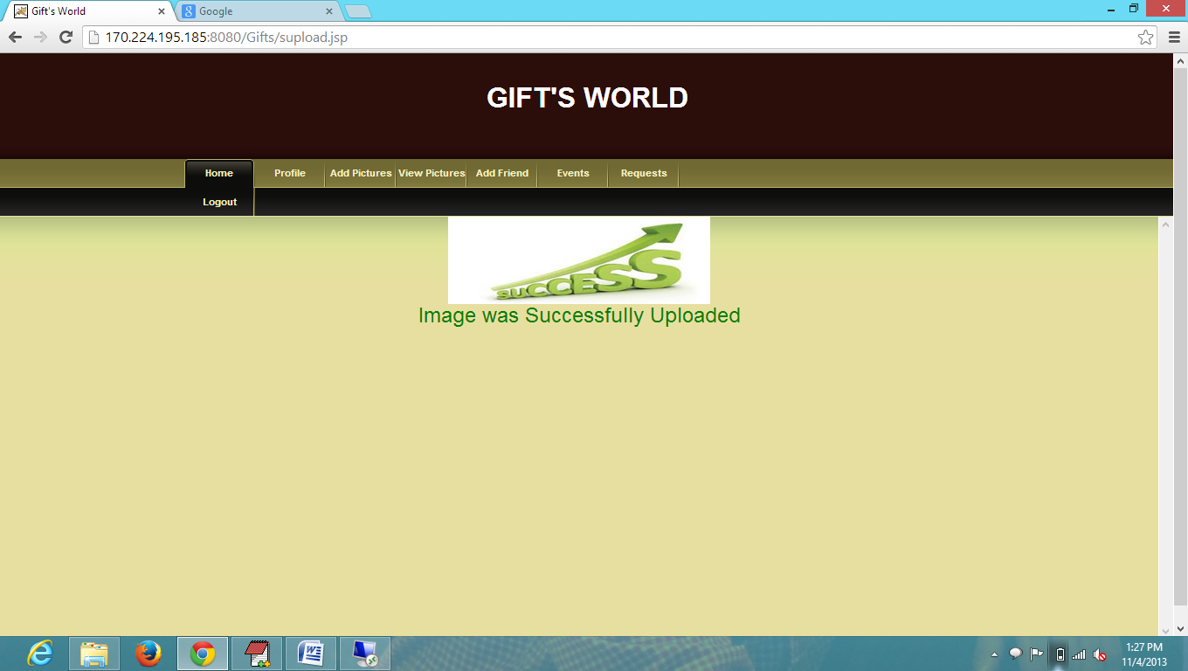

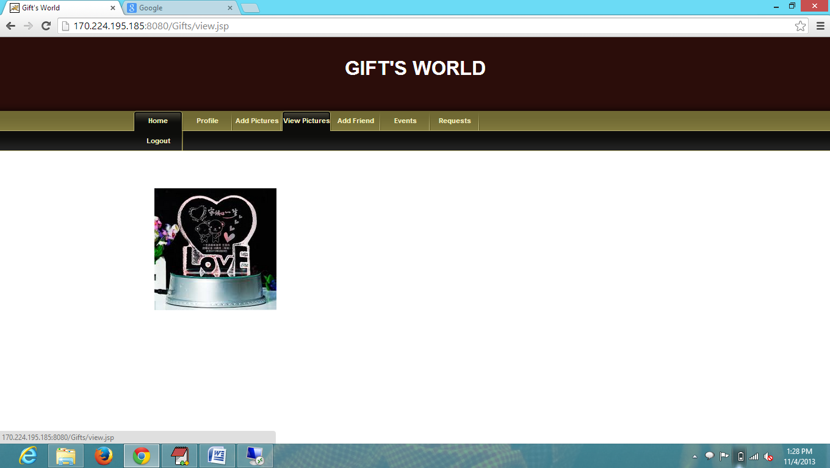

Similarly adding 2 more gifts under user profile

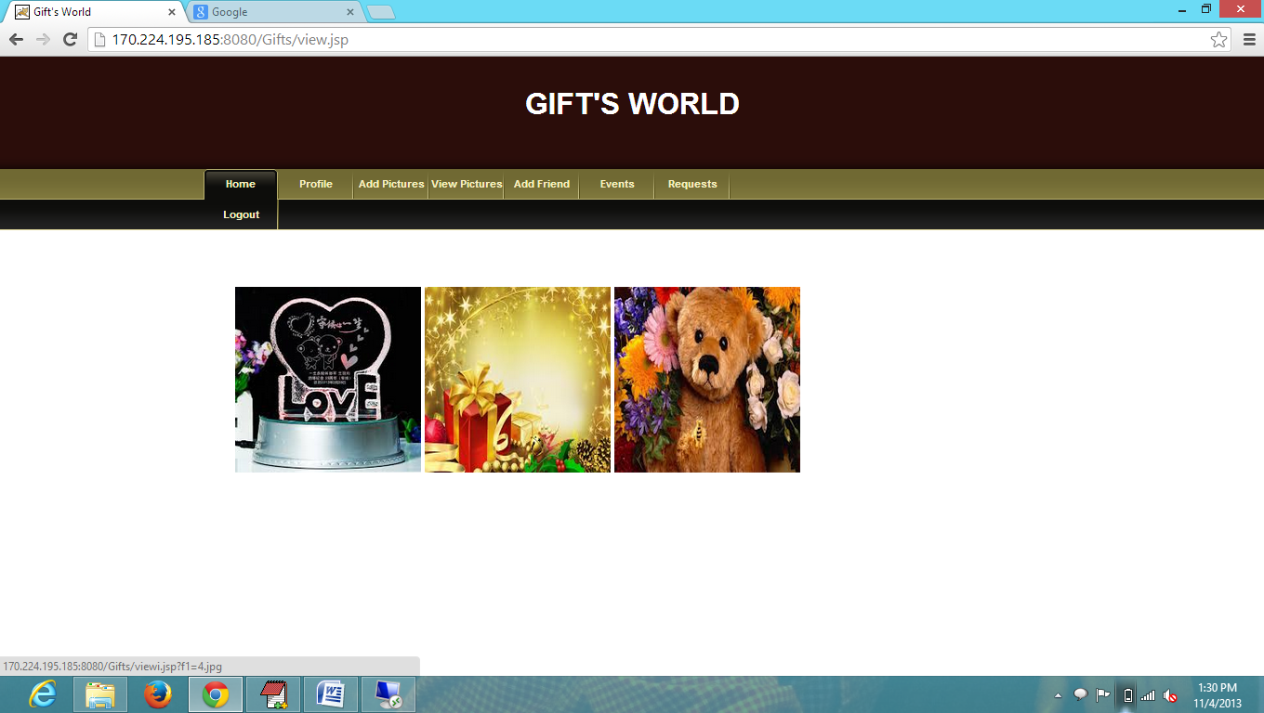

Adding friends to user profile/Sending invitation

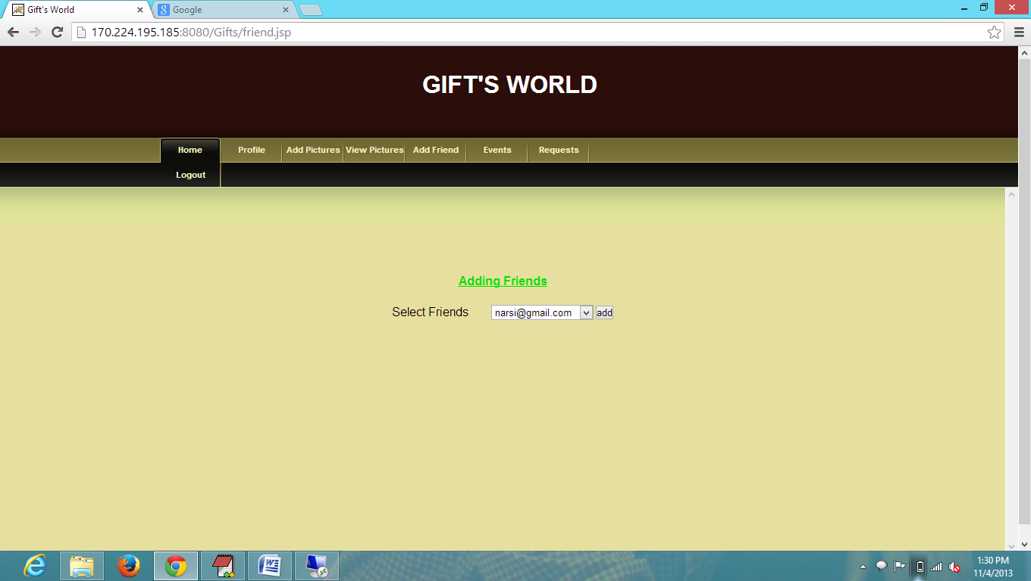

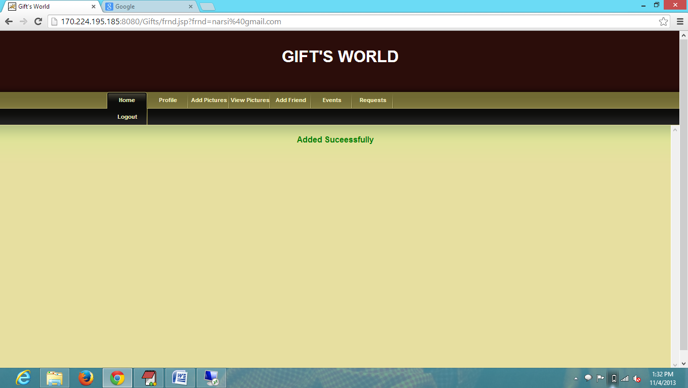

All friend's list is shown under events tab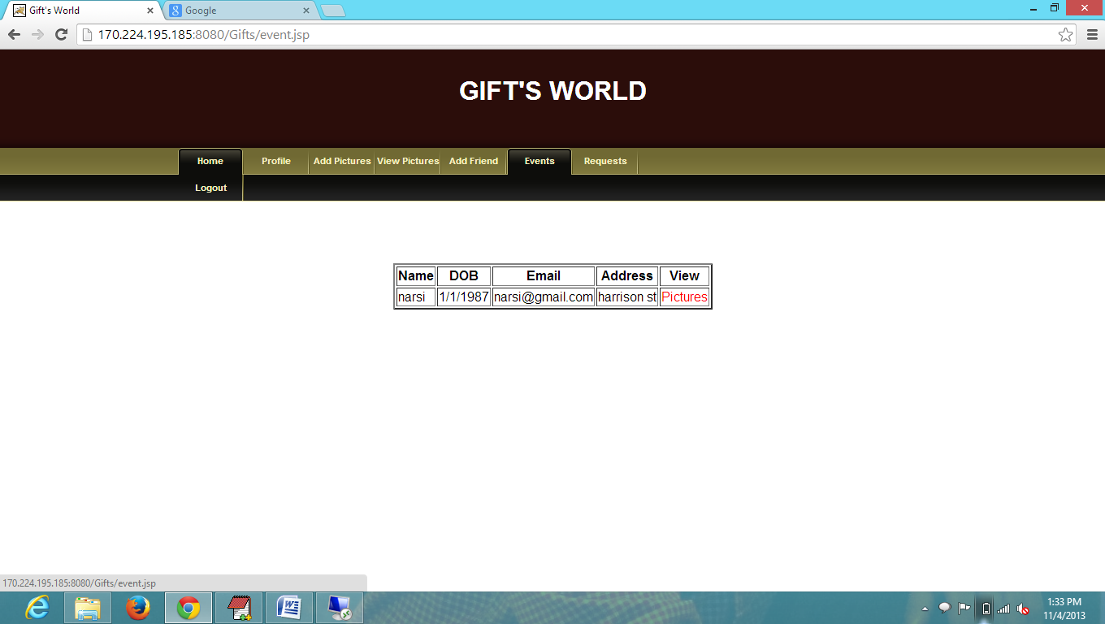

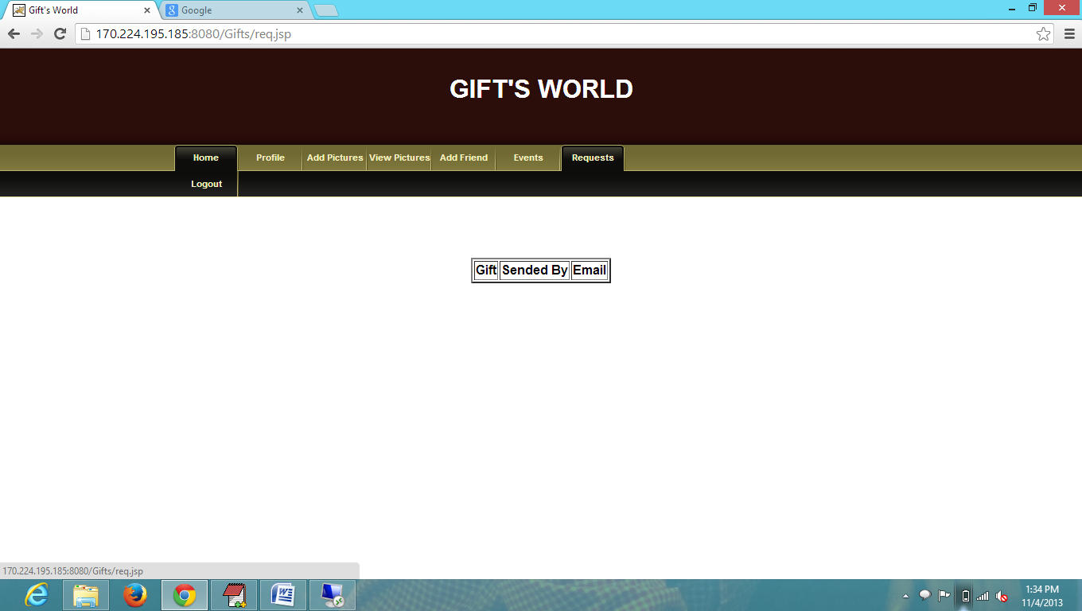

Now Login with other user

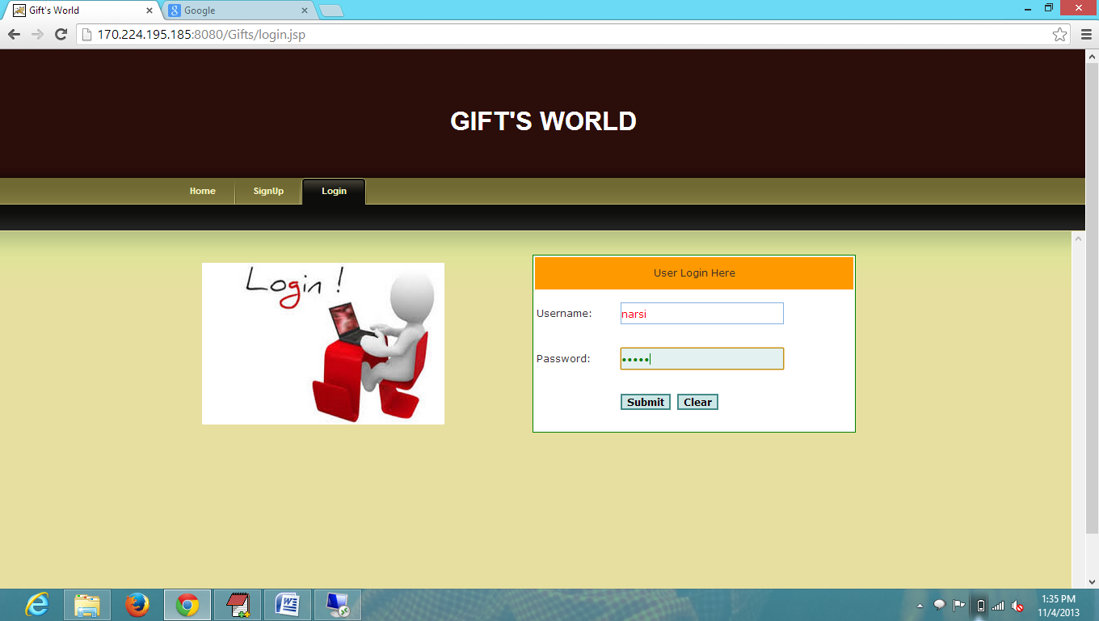

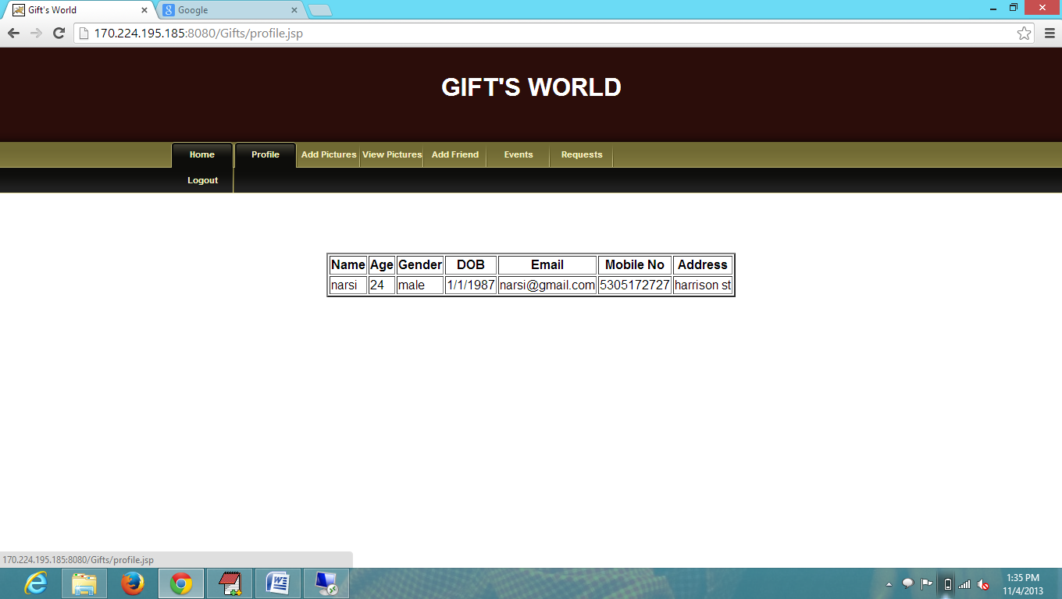

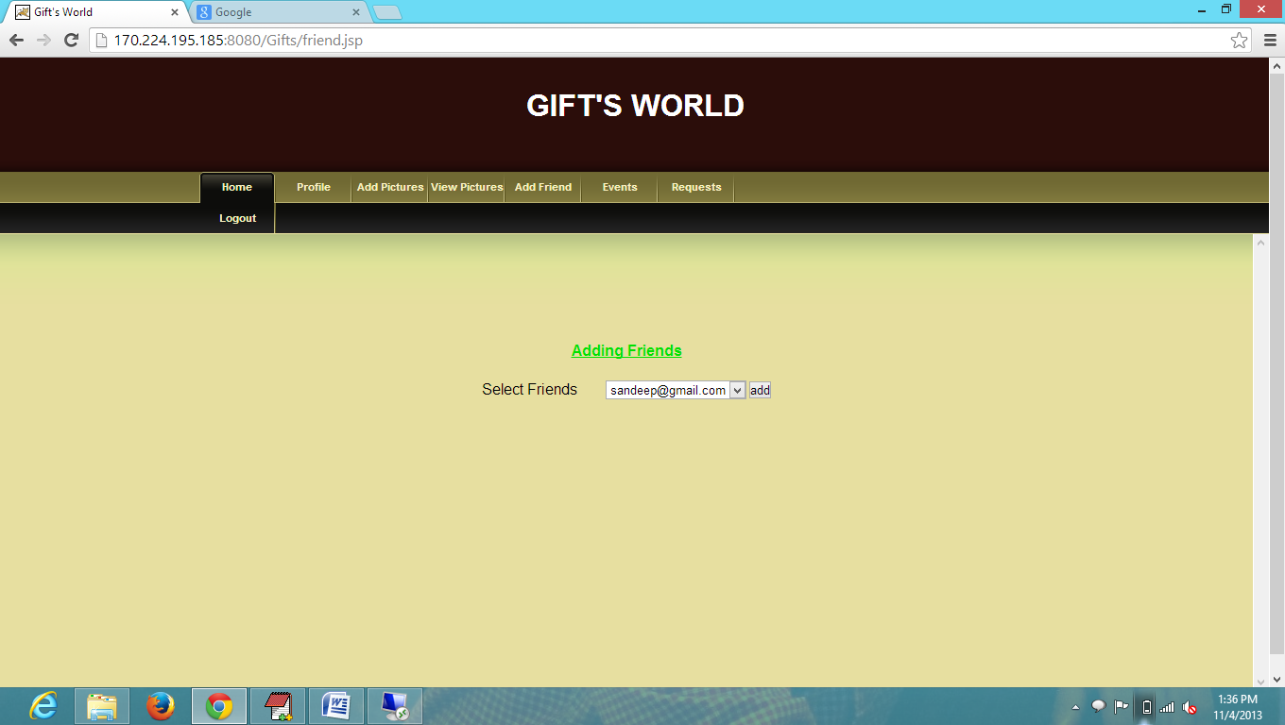

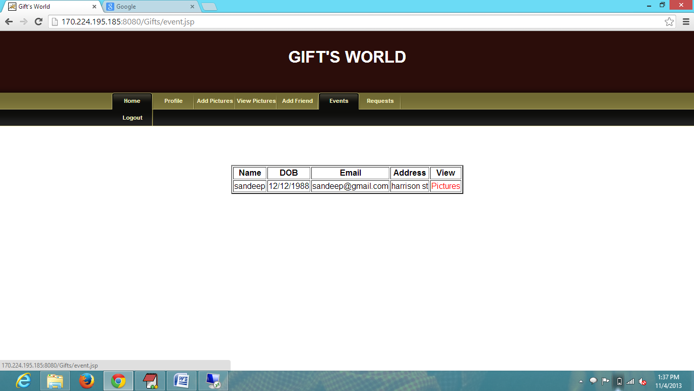

These are the gifts added under first user (sandeep user)

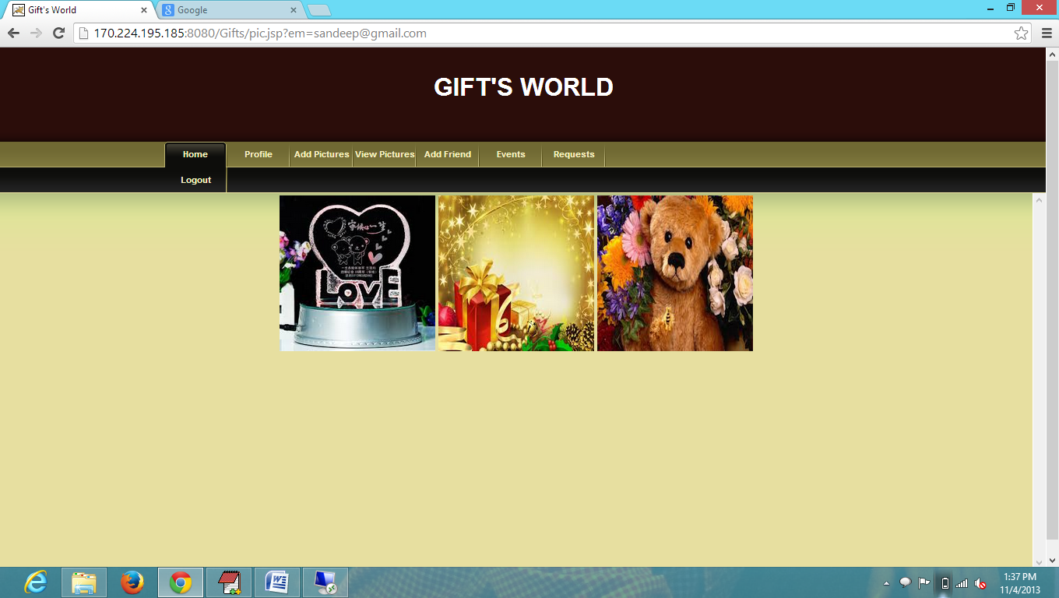

second user selects the gift for first user from the list of first user's gifts

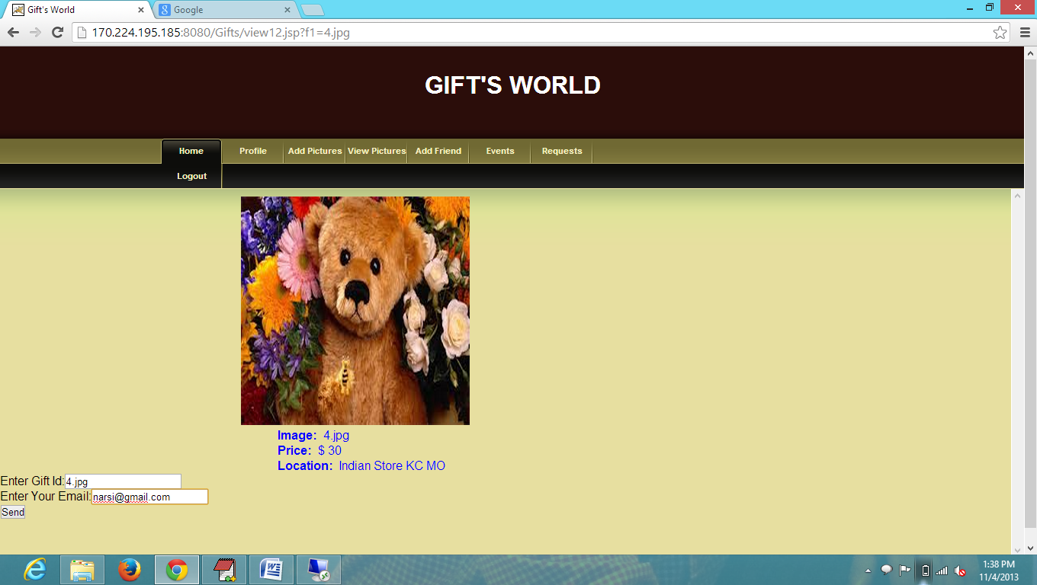

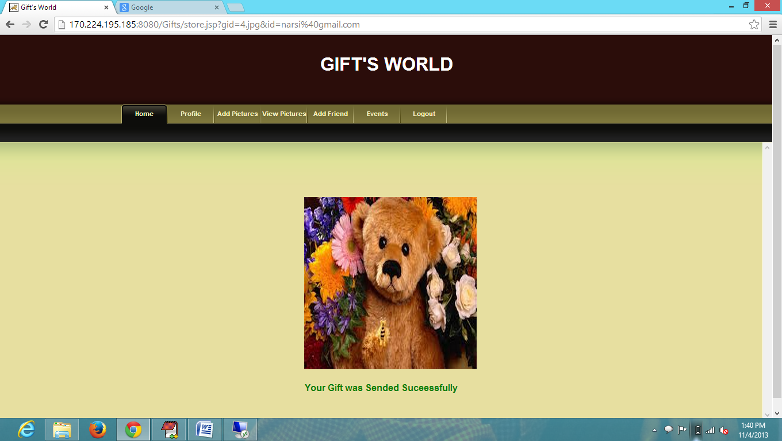

Now login with third user (shanu)

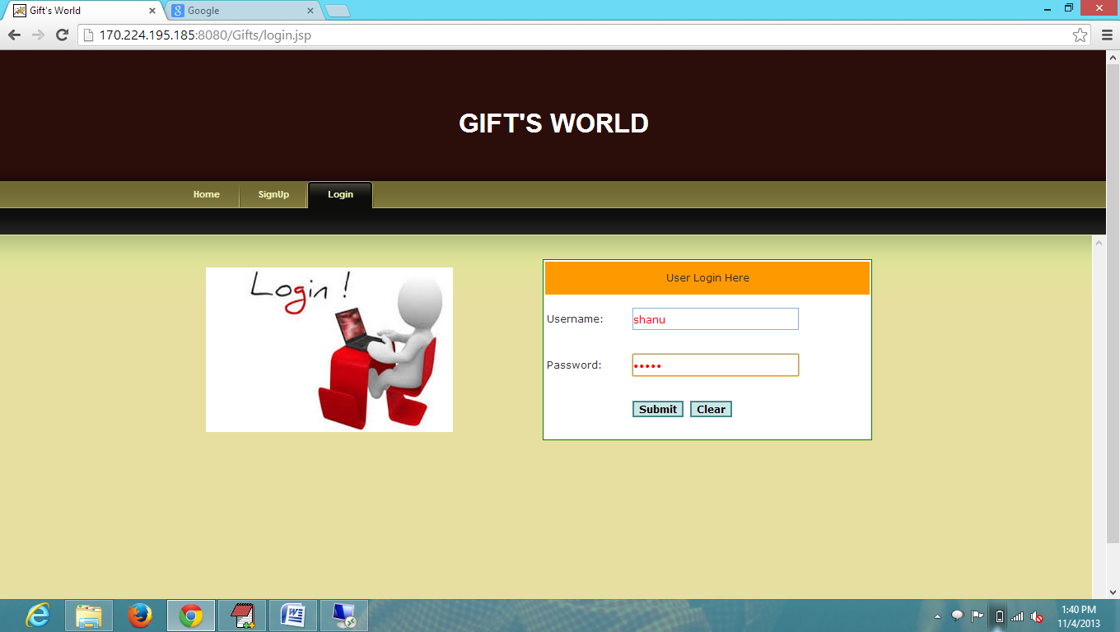

His Profile Information

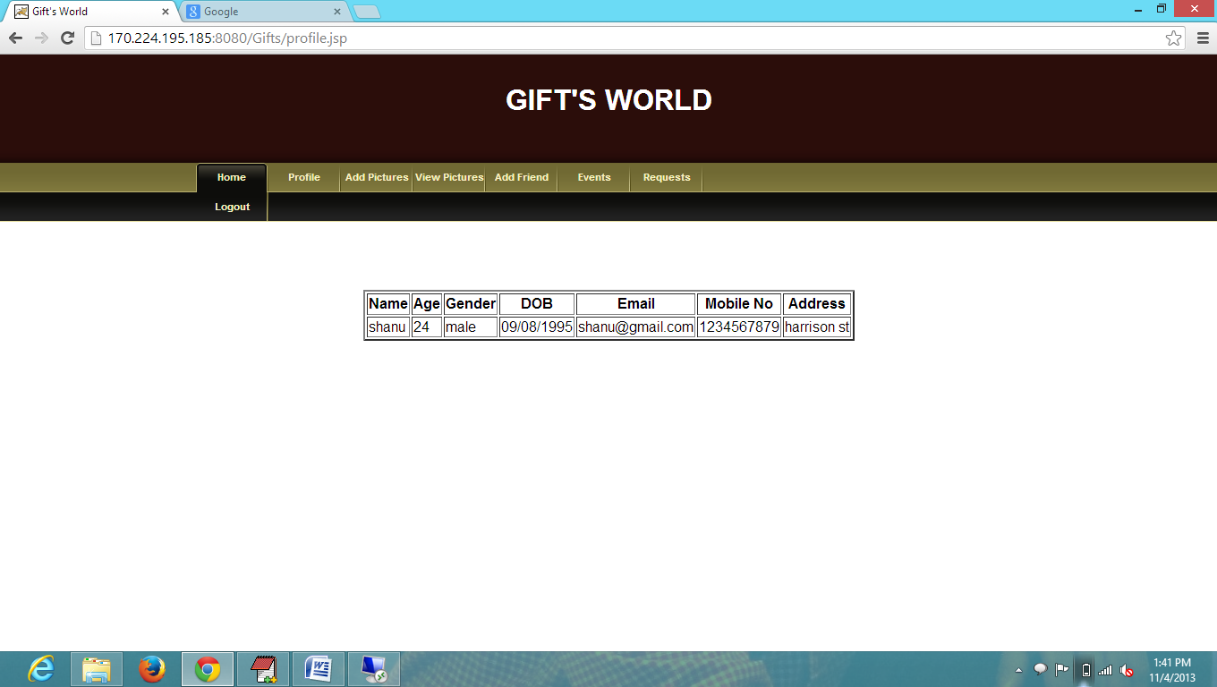

Got the request from first user

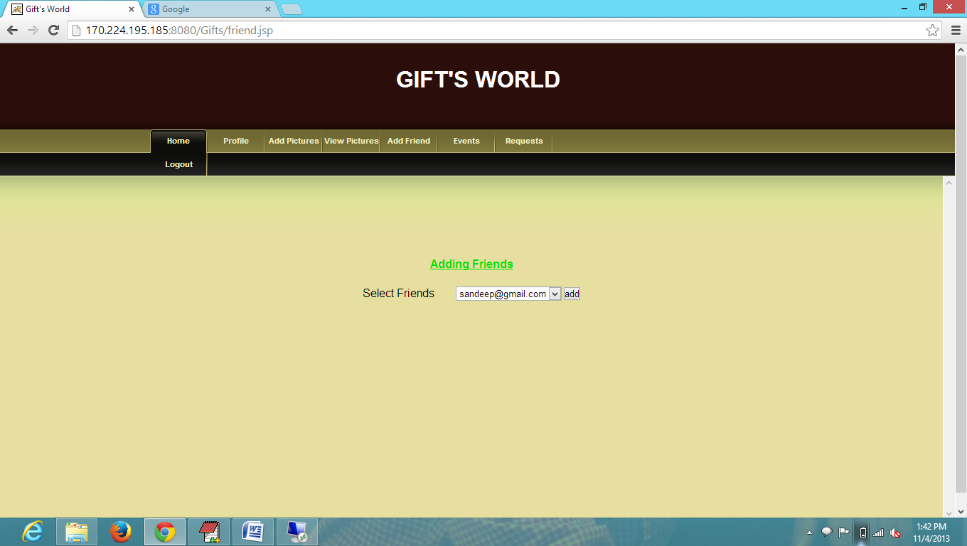

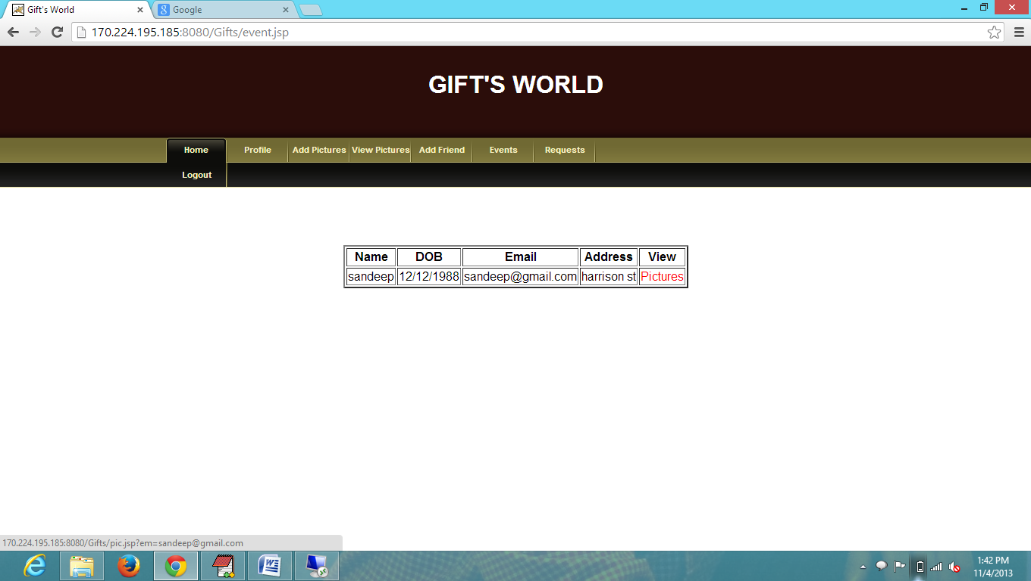

These are under first user and 3rd gift is already selected by second user

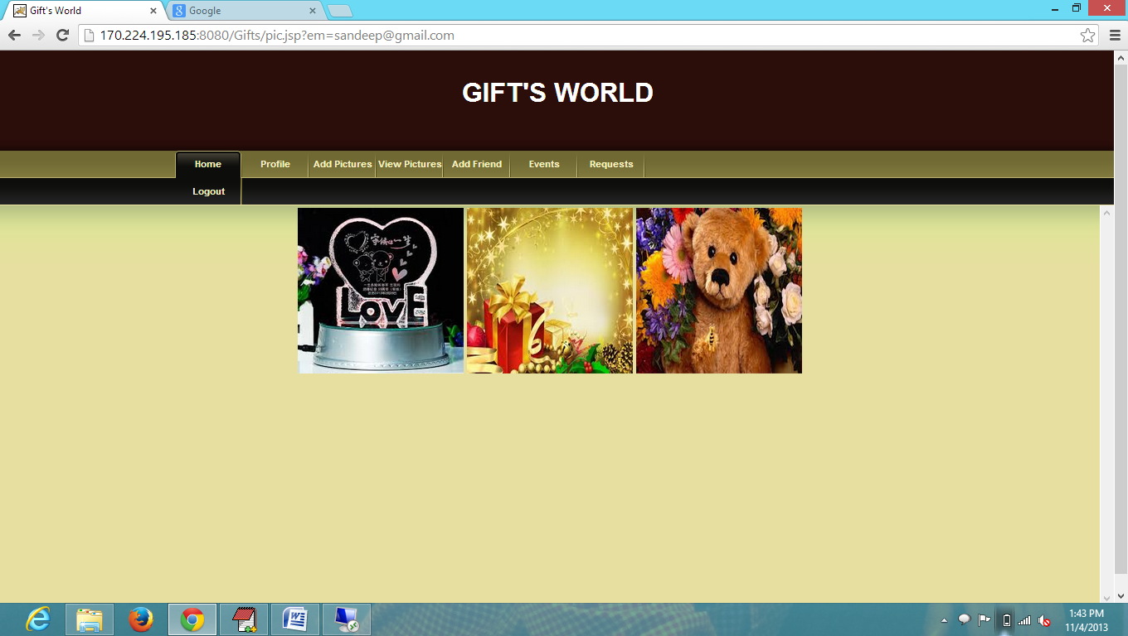

Trying to select third gift again by third user

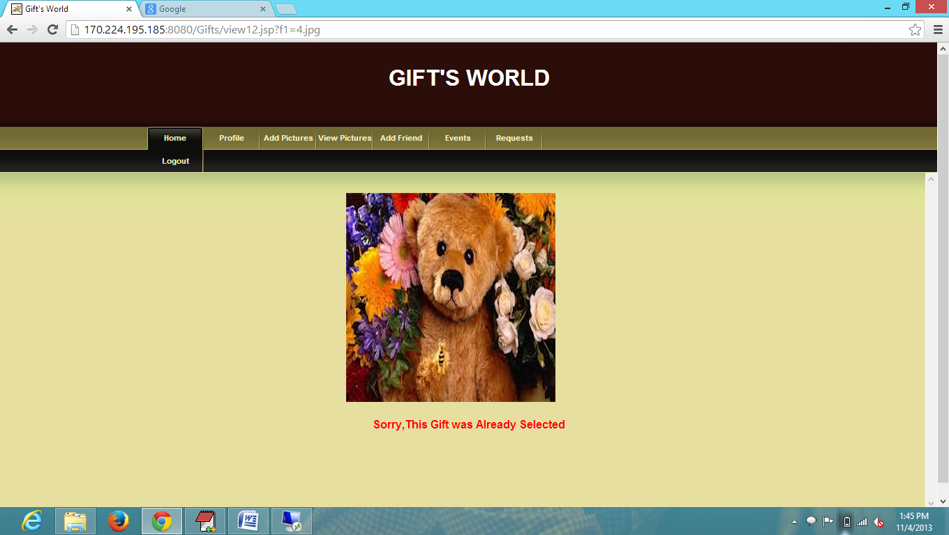

Selecting other gift

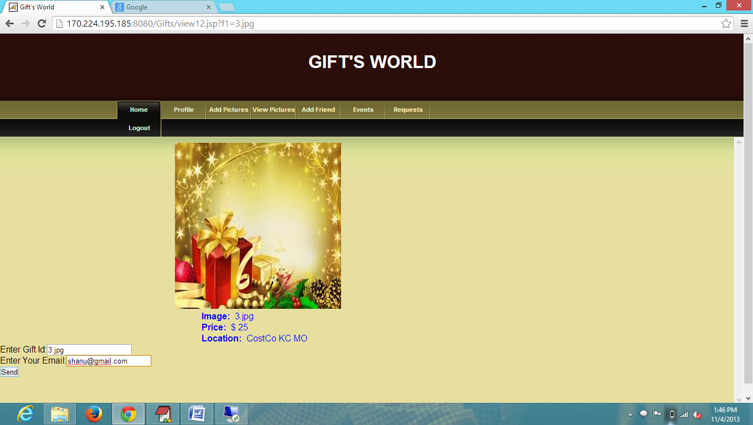

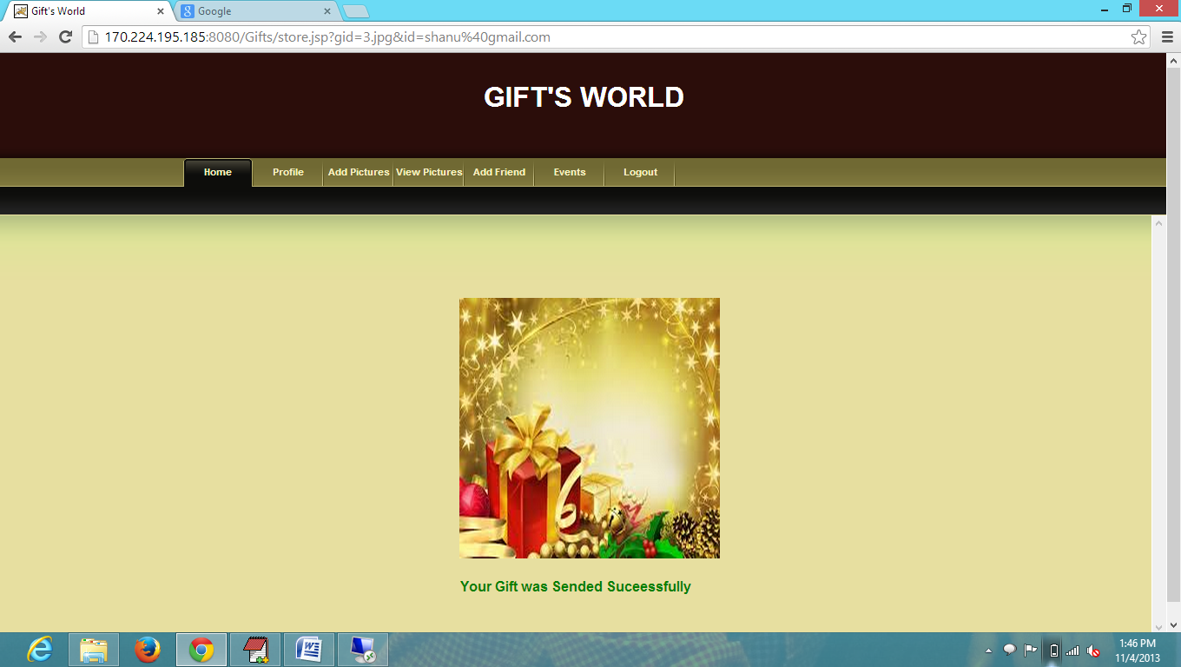

Now login with first user to see his gift requests

